**Spreadsheet**

**Class Six**

**Lab 25**

|  |
| --- |
| Lab Objectives:  * Multiplication * Division |

## Important points to remember about Google Spreadsheet formulas:

## Formulas always begin with the equal sign ( = );

## The equal sign always goes in the cell where you want the answer to go;

## The multiplication operator is the asterisk ( * );

## The formula is completed by pressing the Enter key on the keyboard.

# Using Cell References in Formulas

# Multiplication

No need to mention extra function. Just use cell reference and use * sign to multiply

### Using Cell References in Formulas

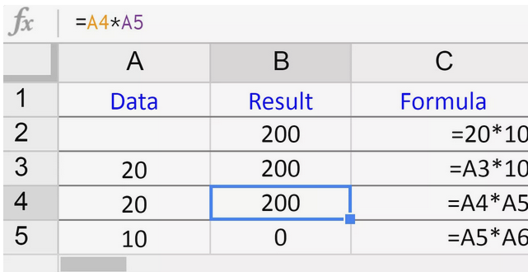

## Multiplication Formula Example

## As shown in the image above, this example creates a formula in cell C4 that will multiply the data in cell A4 by the data in A5.

## The finished formula in cell C4 will be:

## = A4 * A5

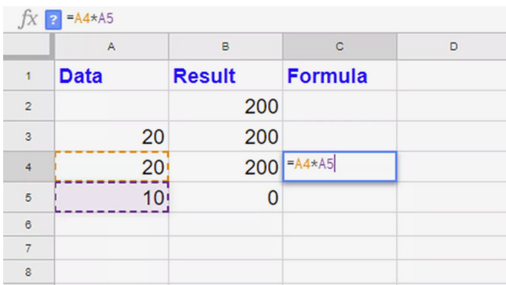

# How to Divide Numbers in Google Sheets Using DIVIDE

## Many Google Sheets users think, there is no DIVIDE function in it. But on the contrary, there is a function called DIVIDE in Google Sheets.

## Let’s see how to use the DIVIDE function in Google Sheets and the concerned operator backslash.

## Syntax:

## = DIVIDE(dividend, divisor)

## Use the Divide function in Google Doc Sheets to return one number (dividend) divided by another (divisor).

****Examples of how to use the Divide function in Google Spreadsheets.****

## If cell A1 contains the number 25 and A2 the number 5, the following Divide formula would return 5.

## =DIVIDE(A1,A2)

## Which is equal to;

## =A1/A2

